**River Processes- Erosion, Transportation and Deposition**

**Task 1:**

For each of the processes of erosion and transportation draw a diagram show the process at work

In the upper course of the main process is **Erosion.** This is where the **bed and banks** of the river are **worn away**. A river can erode in one of four ways:

|  |  |  |
| --- | --- | --- |
| **Process** | Definition | Diagram |
| **Hydraulic action** | the sheer force of water hitting the banks of the river: |  |
| **Abrasion** | fine material rubs against the riverbank The bank is worn away by a sand-papering action called abrasion, and collapses. This occurs on the outside of meanders. |  |
| **Attrition** | material is moved along the bed of a river, collides with other material, and breaks up into smaller pieces. |  |
| **Corrosion** | rocks forming the banks and bed of a river are dissolved by acids in the water. |  |

Once the material is eroded it can then be **transported** by one of four ways, which will depend upon the energy of the river:

|  |  |  |
| --- | --- | --- |
| **Process** | Definition | Diagram |
| **Traction** | large rocks and boulders are rolled along the bed of the river. |  |
| **Saltation** | smaller stones are bounced along the bed of the river |  |
| **Suspension** | fine material which is carried by the water and which gives the river its 'muddy' colour. |  |
| **Solution** | dissolved material transported by the river. |  |

In the middle and lower course, the land is much flatter, this means that the river is flowing more slowly and has much less energy. The river starts to **deposit** (drop) the material that it has been carry

**Deposition**

**Challenge:**

Add labels onto the diagram to show where all of the processes could be happening in the river channel.

What would be happening on the **meanders** (bends in the river)? Hint: think about what happens to as you go round a bend in the road quickly in a car!

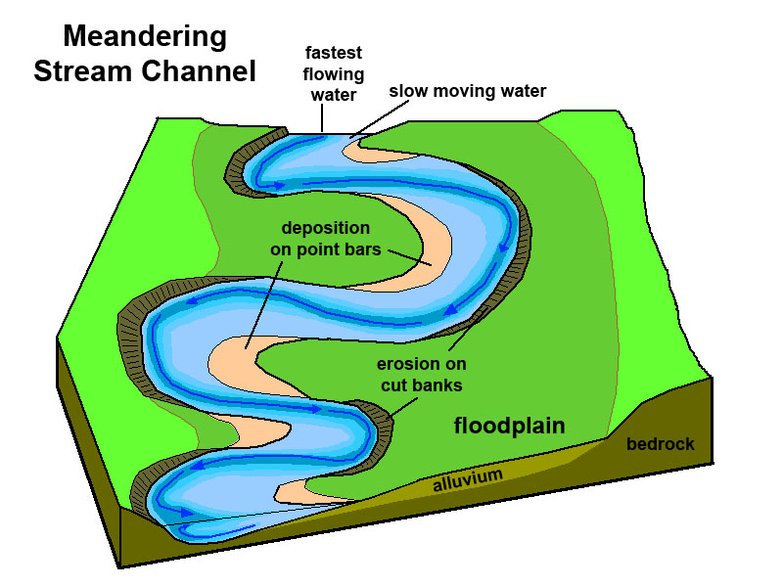

**Super Challenge:**

Use as many keywords from today’s lesson to answer the following question:

**How do river processes work to change the land?**

__________________________________________________________________________________________________________________________________________________________________________________________________________________________________________________________________________________________________________________________________________________________________